**HTML**

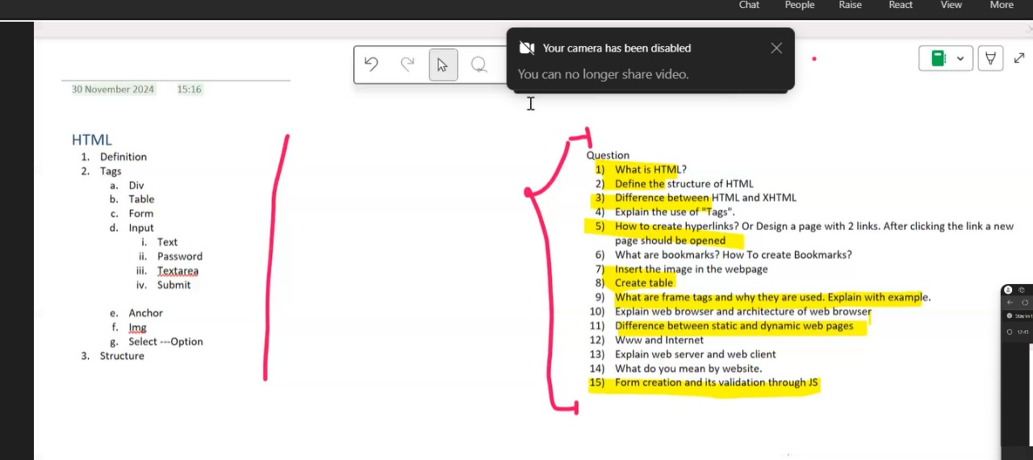

**CSS**

1. What is CSS? What are the advantages of CSS?
2. How many ways a CSS can be used in HTML documents? Or Differential inline CSS, external CSS and Internal CSS.
3. What are selectors in CSS? Explain the different type of selectors in CSS.
4. Explain the Box Model.
5. Explain the Flexbox models and its property
6. Explain the Grid box model and its properties.
7. How can you change the background of a paragraph using CSS.
8. Change the size of the front of text of paragraph when someone mouse over on it.
9. Explain pusedo element with example.
10. Explain media query with example.
11. Explain different types of position with proper syntax. Or explain static, relative, fixed, absolute, sticky CSS position with example.
12. Differentiate Pseudo-classes and Pseudo-elements.

**JS**

1. Differentiate let, var and const.
2. Explain the use od <<script>. Tag
3. How can we use the java script code in HTML.
4. Explain array and object with syntax and example.
5. Explain Document object model.
6. Program
   1. Fibonacci (iteration, recursion)
   2. Factorial (iteration, recursion)
   3. To find even/odd
   4. To sum of all elements in the array.
   5. To get the average of all elements of the given array.
7. Explain different type of variables in JavaScript
8. Explain the hierarchy of objects in java script.

**XML**

1. Differentiate between XML and HTML
2. State the XML syntax rules with a suitable example.
3. What is the namespace? Why do we use it?
4. Explain DTD. Explain the structure of DTD.
5. Create a XML document with a DTD and an XML Schema for validation.
6. Compare the pros and cons of using DTD versus XML Schema.

**JSP**

1. Differentiate between application server and web server
2. Differentiate between servlet and JSP
3. Explain the architecture of JSP and JSP life cycle.
4. Explain different type of JSP elements.
5. Explain JSTL.
6. Describe JSP action tag and JSP Expression Language.
7. Differentiate session and cookies in JSP to manage the session.
8. Develop a JSP page to receive two integers from a text box and display their sum.
9. What are implicit objects in JSP? Explain with example

**JDBC**

1. Explain the steps for database connection with JSP.
2. Explain the components of JDBC.
3. Explain the JDBC Architecture
4. Why do we use JDBC driver? Explain the type of drivers in JDBC?
5. What are the different classes and interfaces used in JDBC.
6. Differentiate forward and redirect.
7. Differentiate statement and prepared statements.
8. Write a JSP page for registration form. The form accepts the input from the user and saves it into database. (**C**reate)
9. Create a JSP page to create login page and validate the username and password from database. (**Read**)
10. Create a JSP page which accepts “userid” and update the “email address” of that entered user. (**Update**)
11. Create a JSP page which accepts a “userid” and deletes the enter “userid” from the database. (**Delete**)